Installation

The following installation steps were tested on a Jetson TX2 and Jetson Nano, but should apply to any Jetson Platform (Xavier, Xavier NX) or Desktop Computers with Ubuntu.

**Configure packages sources**

sudo sh -c 'echo "deb http://packages.ros.org/ros/ubuntu $(lsb_release -sc) main" > /etc/apt/sources.list.d/ros-latest.list'

sudo apt-key adv --keyserver 'hkp://keyserver.ubuntu.com:80' --recv-key C1CF6E31E6BADE8868B172B4F42ED6FBAB17C654

sudo apt update

**Install ROS from packages**

You can choose from one of the following options:

1.**Desktop-Full Install (Recommended):** ROS, rqt, rviz, robot-generic libraries, 2D/3D simulators and 2D/3D perception

sudo apt install ros-melodic-desktop-full

2.**Desktop Install:** ROS, rqt, rviz, and robot-generic libraries

sudo apt install ros-melodic-desktop

3.**ROS-Base: (Bare Bones):** ROS package, build, and communication libraries. No GUI tools.

sudo apt install ros-melodic-ros-base

To find available packages, use:

apt search ros-melodic

Configure ROS

Before you can use ROS, you will need to initialize rosdep. rosdep enables you to easily install system dependencies for source you want to compile and is required to run some core components in ROS.

To install ROS initializer:

sudo apt-get install python-rosdep -y

sudo apt-get install python-rosinstall python-rosinstall-generator python-wstool build-essential -y

sudo c_rehash /etc/ssl/certs

Then execute:

sudo rosdep init

rosdep update

Environment Setup

It's convenient if the ROS environment variables are automatically added to your bash session every time a new shell is launched:

echo "source /opt/ros/melodic/setup.bash" >> ~/.bashrc

source ~/.bashrc

Execute ROS

You will need to launch ROS process from a terminal:

roscore

Which will generate an output similar to the following:

nvidia@nvidia-desktop:~$ roscore

... logging to /home/nvidia/.ros/log/5ee9868e-6a1f-11ea-b91d-00044bf25e44/roslaunch-nvidia-desktop-20965.log

Checking log directory **for** disk usage. This may take a **while**.

Press Ctrl-C to interrupt

Done checking log file disk usage. Usage is <1GB.

started roslaunch server http://nvidia-desktop:39719/

ros_comm version 1.14.4

SUMMARY

========

PARAMETERS

* /rosdistro: melodic

* /rosversion: 1.14.4

NODES

auto-starting new master

process[master]: started with pid [20976]

ROS_MASTER_URI=http://nvidia-desktop:11311/

setting /run_id to 5ee9868e-6a1f-11ea-b91d-00044bf25e44

process[rosout-1]: started with pid [20987]

started core service [/rosout]

To verify ros was correctly launched, from another terminal, while keeping the last one opened, you can run **rosnode list**

nvidia@nvidia-desktop:~$ rosnode list

/rosout

Intel RealSense Camera Support

**Installation**

For the melodic ROS distribution

sudo apt-get install ros-melodic-realsense2-camera

Default resolution may not be configured, you can check video format and size with

v4l2-ctl --device /dev/video3 --list-formats-ext

Apply correct settings to all available modes at:

sudo vim /opt/ros/melodic/share/realsense2_camera/launch/rs_camera.launch

For example for depth mode, introduce correct width and height and true to enable camera stream:

...

**<arg** name="depth_width" default="480"**/>**

**<arg** name="depth_height" default="270"**/>**

**<arg** name="enable_depth" default="true"**/>**

...

**Install ROS Visualizer**

sudo apt-get install rviz

**Start Camera Streaming**

To use the camera with ROS, you will need to execute 3 processes, to ease the steps using **terminator** is recommended.

1. Run ROS core

roscore

2. Run ROS visualizer

rviz

3. Run ROS realsense camera

roslaunch realsense2_camera rs_camera.launch filters:=pointcloud

As follows:

[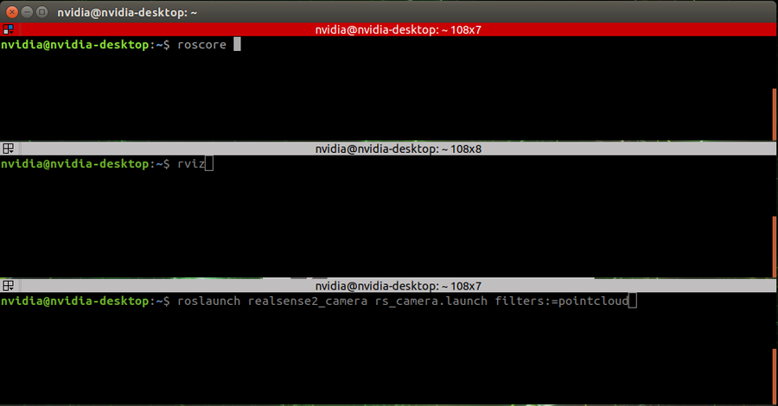](https://developer.ridgerun.com/wiki/index.php?title=File:ROS_Realsense_Camera_Step_1.png)

**Use RVisualizer**

On the Visualizer

1. Click the Add button to add a new source

[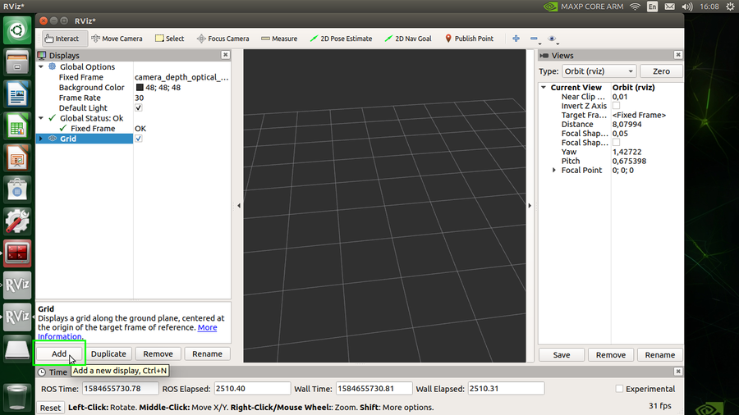](https://developer.ridgerun.com/wiki/index.php?title=File:ROS_Realsense_Camera_Step_2.png)

2. Click the By topic tab, and then **DepthCould**. Repeat to also add **Image**.

[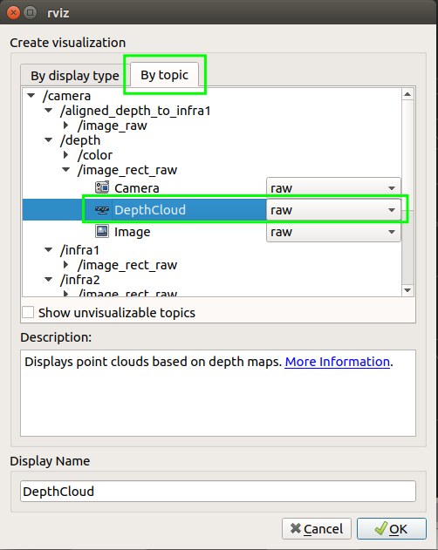](https://developer.ridgerun.com/wiki/index.php?title=File:ROS_Realsense_Camera_Step_3.png)

3. You will get a view similar to the following

[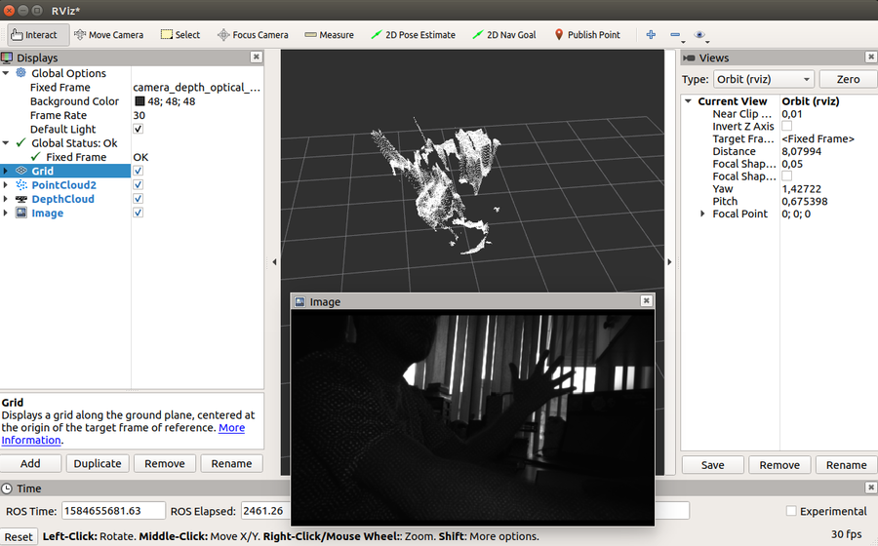](https://developer.ridgerun.com/wiki/index.php?title=File:Rviz_camera_view.png)

**Use IntelRealsense Visualizer**

The IntelRealsense library also includes its own visualization tool, that can be executed with:

realsense-viewer

Some configurations can be seen in the following image:

[1] **Add source:** if the camera is not detected by default, please try to disconnect and reconnect it to the usb port and click this button.

[2] **On/off** click this button to enable/disable camera streams.

[3] **Stream settings** Select required resolution and framerate.

[4] **Select streams** Choose the streams to be displayed.

[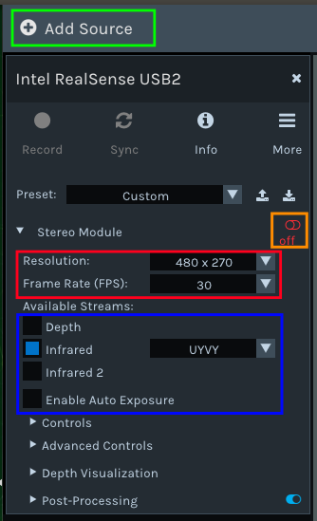](https://developer.ridgerun.com/wiki/index.php?title=File:Config_realsense.png)

For example with a single infrared stream you will get the following output:

[](https://developer.ridgerun.com/wiki/index.php?title=File:Realsense2.png)